# BANK MANAGEMENT SYSTEM

# Core Java Project

Presented by:-Ruchita Vishnu Raut

Guided by :Indrakka Mali

Batch Code:2022-8643

**CORE JAWA PROJECT**

**PROJECT TITLE : Bank Management System**

**Objective :**

The main objective of the project is to develop online Banking system for Customers**.**

**Abstract :**

The main objective of the system is to automate all the banking process with improved performance an realize the vision of paperless banking. As all the manual work will be done automatically so it will increase work speed and reduce time consumption to complete any bank related work. It will also increase the work efficiency as few employees can handle more customers. This will reduced the manual workload and give information instantly.

Through this bank management system user can manage all bank account activity like deposite money, withdraw money.Using this bank management system user can check his account detail online like balance in account.

**INTRODUCTION**

The present system all banking work is done manually. User have to visit bank to Withdrawal or Deposite amount. In present bank system it is also difficult to find account information of account holder. In this bank management system we will automate all the banking process. This Online Bank Management System is an online software designed in Java programming language for the purpose of effective online banking system. It mainly aims at making the banking system easily accessible from anywhere and improving and enhancing the running banking process. With the use of this online software, bank customers don’t need to go to bank to make inquiry regarding their balance or to transfer their balance to other account or for any other banking service.

In this Bank Management System there are some main operation.

* Check balance :- by using this operation user can check the balance.
* Deposite the amount :- by using this operation user can deposite the money.
* Withdraw the cash :- :- by using this operation user can withdraw the cash.
* Check Balance :- User can see the available balance.

**Language:-**

* JAVA

**Software Required:-**

* Eclipse for java

**INITIAL SETUP**

Project Name:Bank Management System

Package name:-Bank

Class Name:-Bank_sys

**Source Code**

Here I have Created a switch case to perform operation.

There is four option one is Check the balance, withdraw the money, Deposite the money and exit.By choosing this option user can perform the above operation**.**

**package** bank;

**import** java.util.Scanner;

**public** **class** bank_sys

{

**public** **static** **void** main(String[] args)

{

**int** balance=10000,withdraw,deposite,number;

Scanner Sc=**new** Scanner(System.***in***);

**while**(**true**)

{

System.***out***.println("Welcome TO Bank");

System.***out***.println("1.for Withdrawn");

System.***out***.println("2. for Deposite");

System.***out***.println("3. for Check Balance");

System.***out***.println("4.for EXIT");

System.***out***.print("Choose the operation you want to perform:");

number = Sc.nextInt();

**switch**(number)

{

**case** 1:

System.***out***.print("Enter amount to be withdrawn :");

withdraw = Sc.nextInt();

**if**(withdraw <0) {

System.***out***.println("sorry,but your amount must be positive");

}

**else** **if**(balance >= withdraw)

{

balance = balance - withdraw;

System.***out***.println("Balance amount is:"+balance);

System.***out***.println("Please collect your money");

}

**else**

{

System.***out***.println("You dont have enough money for withdraw");

}

System.***out***.println(" ");

**break**;

**case** 2:

System.***out***.println("Enter amount to be deposited:");

deposite = Sc.nextInt();

**if**(deposite<0)

{

System.***out***.println("sorry,but your amount must be positive");

}

**else**

{

balance = balance + deposite;

System.***out***.println("Balance amount is:"+ balance);

System.***out***.println("Money has been deposited successfully !!!");

System.***out***.println(" ");

}

**break**;

**case** 3:

System.***out***.println("Balance of your amount is:"+balance);

System.***out***.println(" ");

**break**;

**case** 4:

System.***out***.println(" THANK YOU !!!");

System.*exit*(0);

}

}

}

}

**Output:-**

**1.Welcome Screen**

Firstly,User can view welcome Screen and choose the operation want to perform.

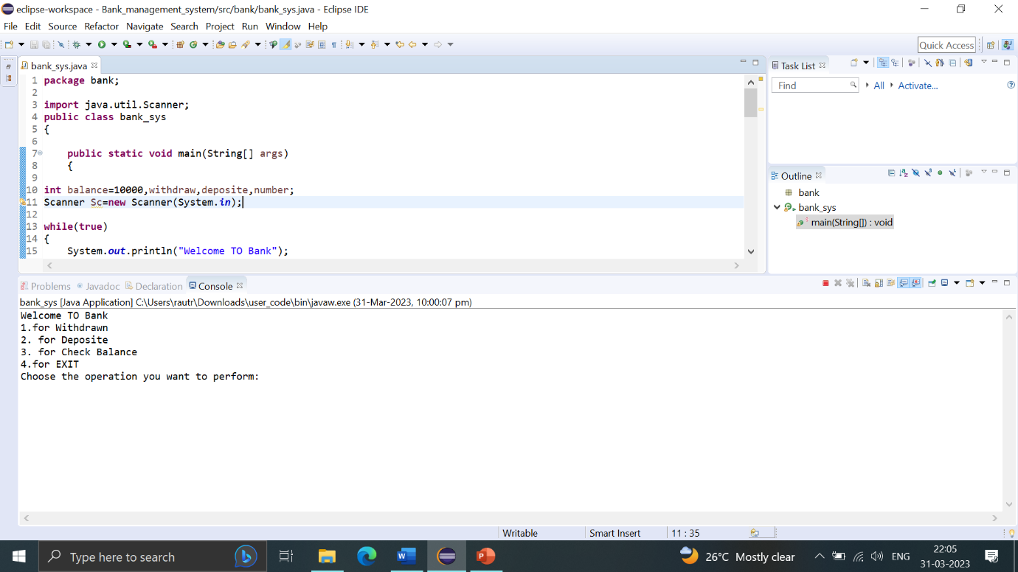

**2. For Withdraw Amount**

a): For withdraw amount user can enter no 1 and entered how much amount withdraw.

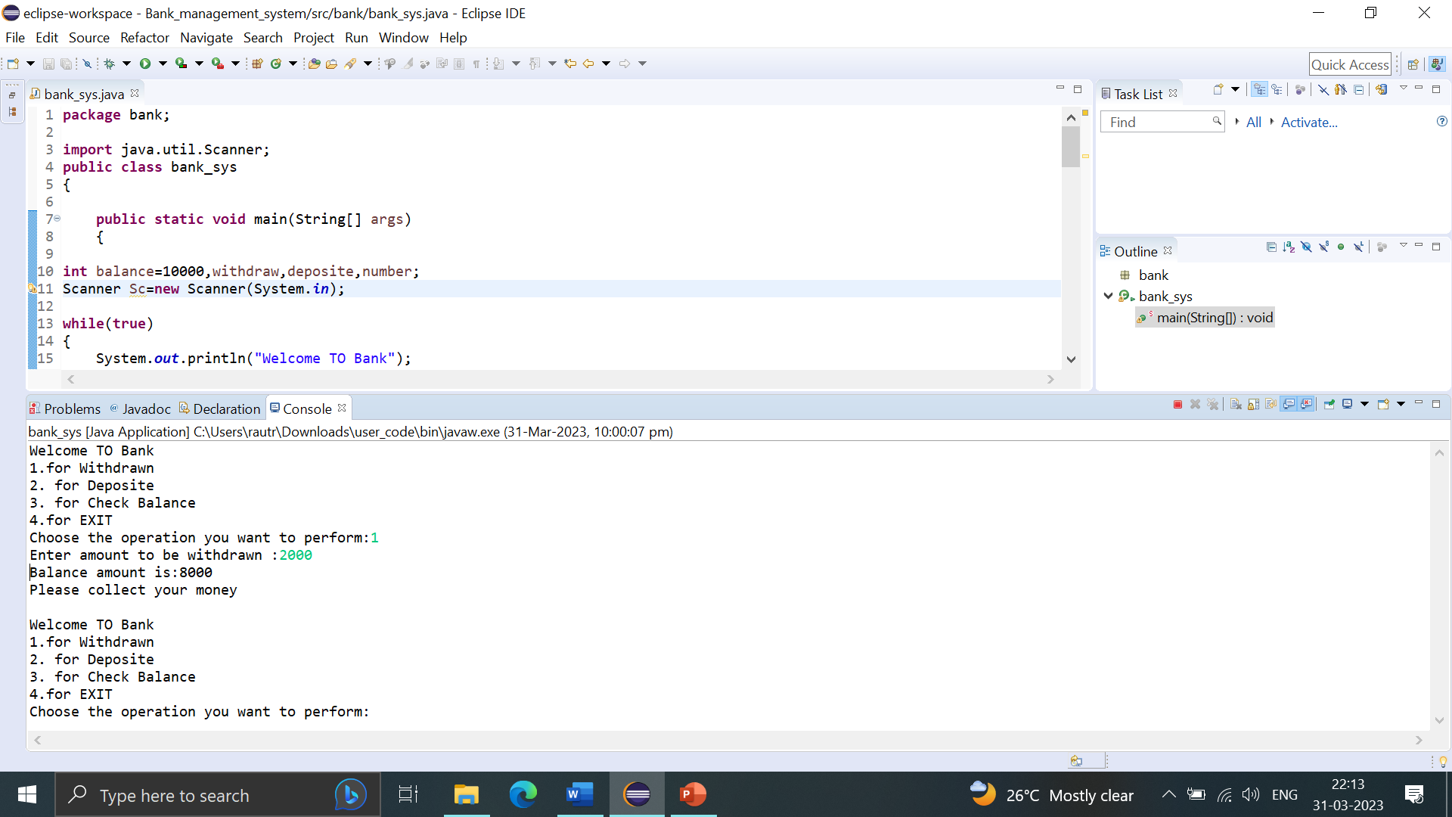

b)if user entered negative amount

if user entered negative amount then the message will display on screen.

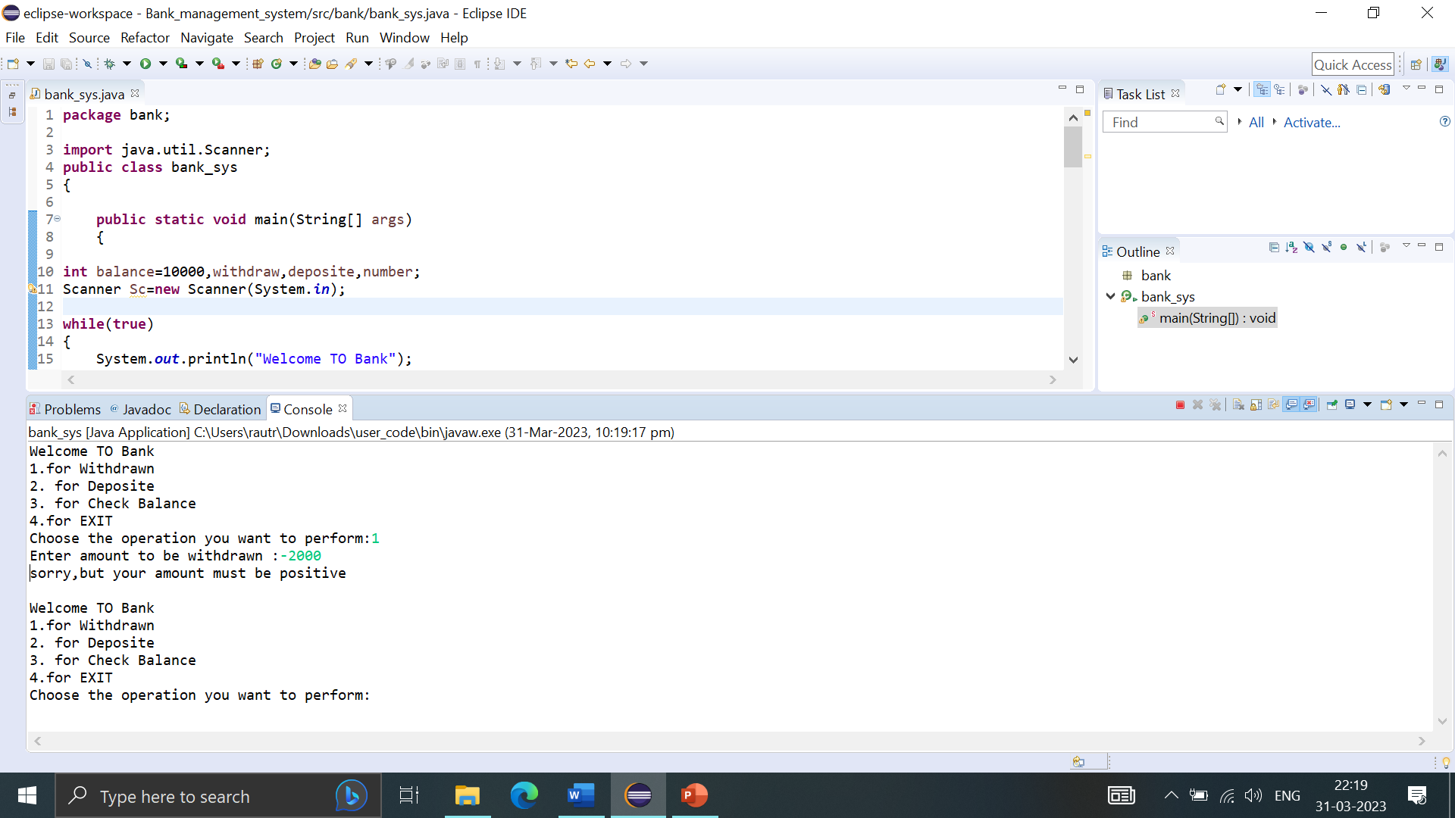

c) if user entered amount greater than balance amount **:**

if user entered the amount greater than balance amount then u don’t have a sufficient balance this type of message is shown.

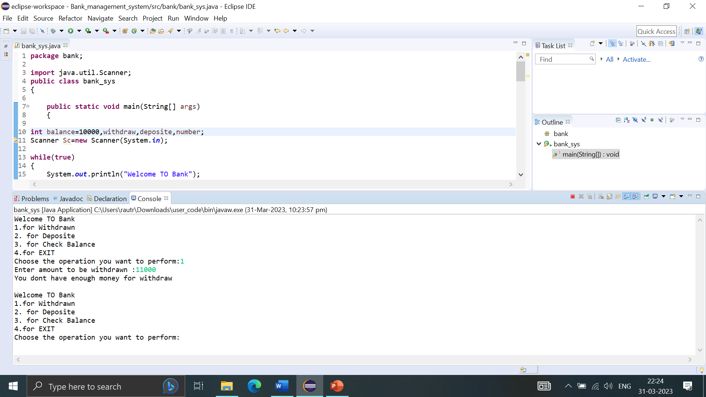

**3. For deposite amount**

For deposite amount user can enter no 2 and entered how much amount deposite.

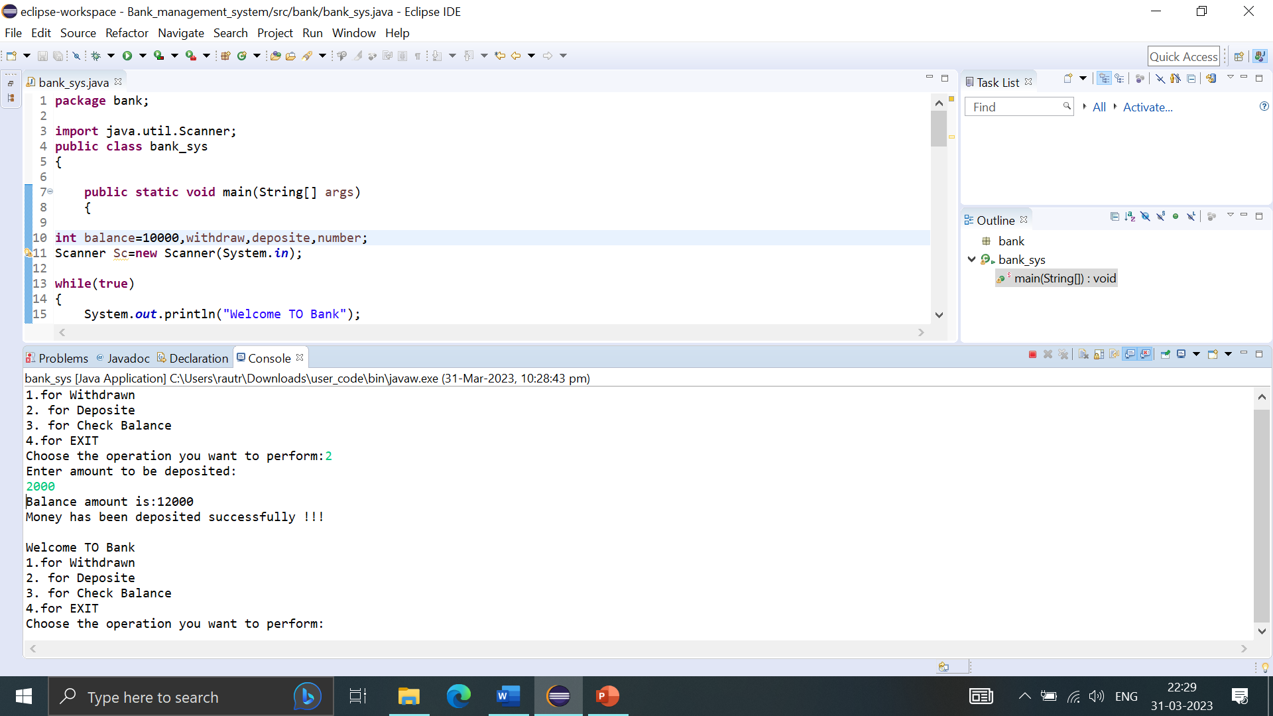

**4. For Check balance**

For check balance user can enter no 3 and see the balance amount on screen.

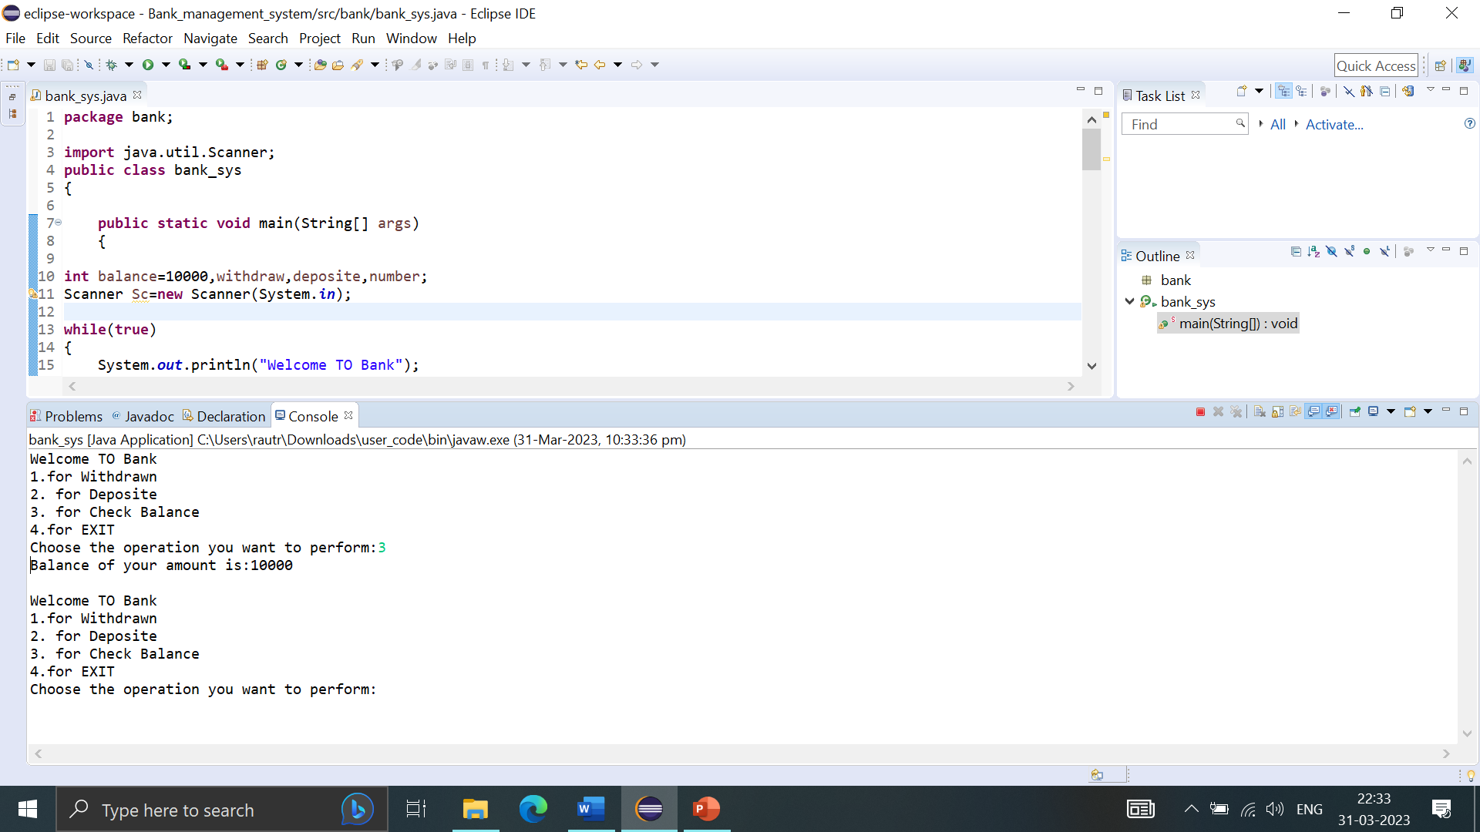

**5.For Exit**

For exit user can enter no 4 and see the thank you on screen.

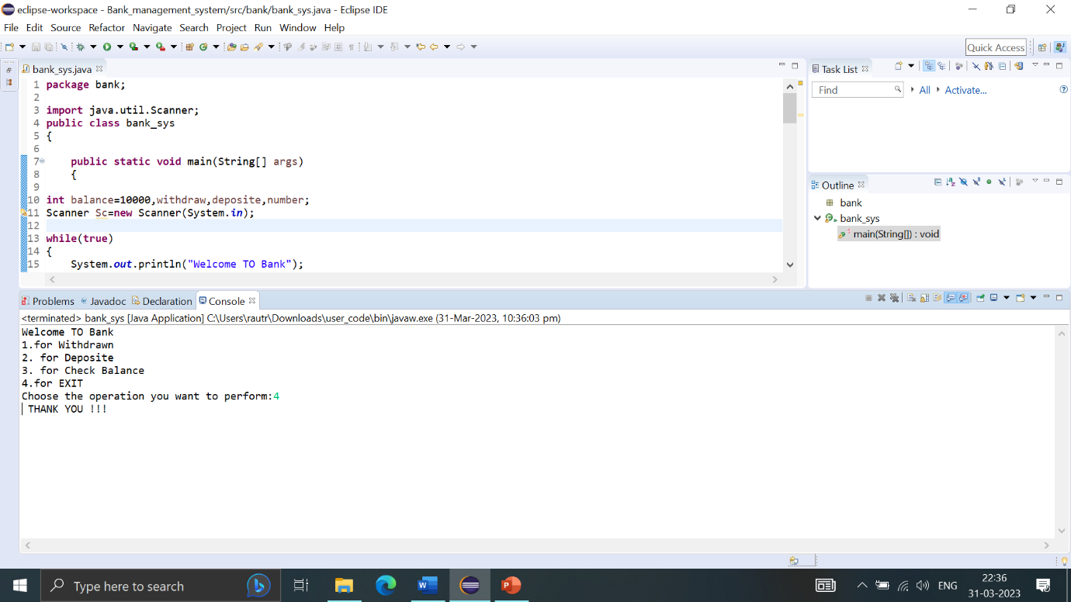

**Conclusion:-**

Creating an bank Management System Program using Java,we need to implement the four fundamental concept of each bank management system that exist,it includes Cash Withdrawl,Cash deposite,account balance checks .